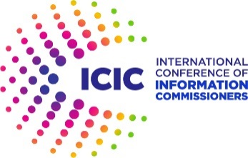

Observer application form

Is your entity responsible for protecting, promoting and ensuring the respect of access to public information legislation in your jurisdiction?

If yes, you might consider filling the membership accreditation form on the ICIC website (https://www.informationcommissioners.org/accreditation).

If no, please provide as much detail as possible in the form below.

1. Identity

Name of your entity:
Legal Name (if different):
Jurisdiction:
Country (if different from jurisdiction):

2. Representatives

Name and title of the head of the entity:
Name of the official representative:
Title of the official representative:

3. Vision and values

Mission, vision and goals of your entity:
Founding Act:
Current priorities:

4. Interest in ATI

Please describe your involvement or interest in the development, research, protection and promotion of right to access to public information

5. ATI legal framework in your jurisdiction

If one exists, indicate the relevant access to information legislation in your jurisdiction. Please provide a link to the relevant legislation.

Is there an authority responsible for protecting, promoting and ensuring the respect of access to public information legislation in your jurisdiction?
Yes No

If yes, please identify the authority or authorities:

If available, please provide the name and contact details of a representative from each of the authorities mentioned in the question above

6. Adherence to the values, goals and missions of the International Conference

Please confirm that you adhere to the values, goals and missions of the International Conference as enshrined in the Johannesburg Charter:

Please provide an additional comments in support of your application, including your entity’s expectations of the ICIC, such as bilateral cooperation, specific project collaboration, exchange of knowledge, networking, training, etc.

7. Contact details

Contact name:
Contact email:
Job title/role in the authority:
Contact telephone number:

Once completed, the Form must be sent to the ICIC Secretariat
(icic-secretariat@inai.org.mx).

The Secretariat will progress your application and inform you of the ICIC Executive Committee’s decision.

For further information about the registration process, please refer to www.informationcommissioners.org

